Mechanics of Flexible Structures and Soft Robotics Homework 4
Luke Sage
Part 1: Single Load Level
A simulation of the helical spring was run for F = F_{char}. Figures 1-5 show the displacement over several time values. It is important to note that at the characteristic force, little deformation is visible.

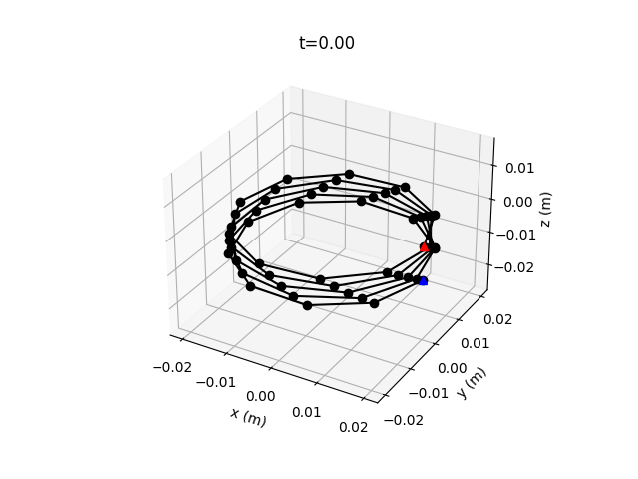
Figure 1: Snapshot of helix at t = 0.0s
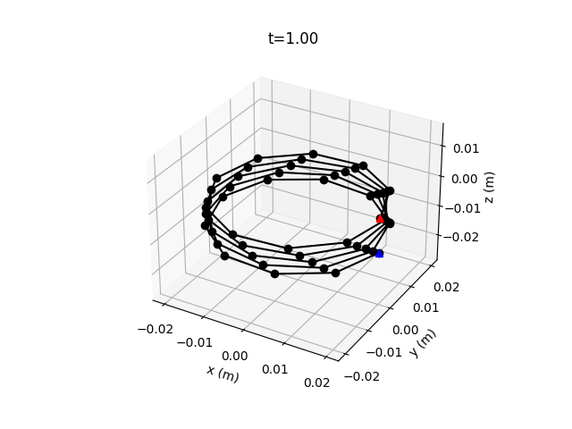
Figure 2: Snapshot of helix at t = 1.0s
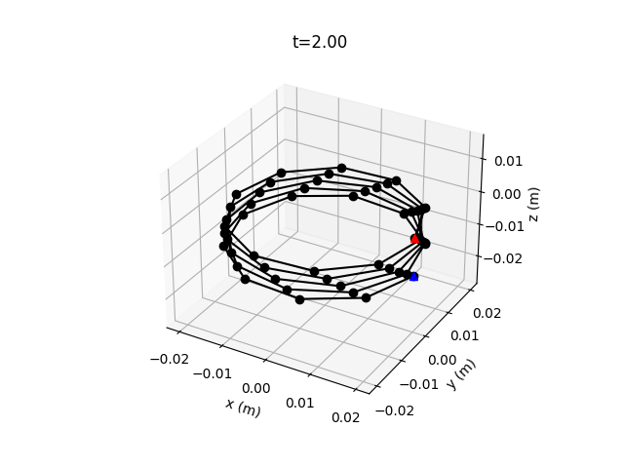
Figure 3: Snapshot of helix at t = 2.0s
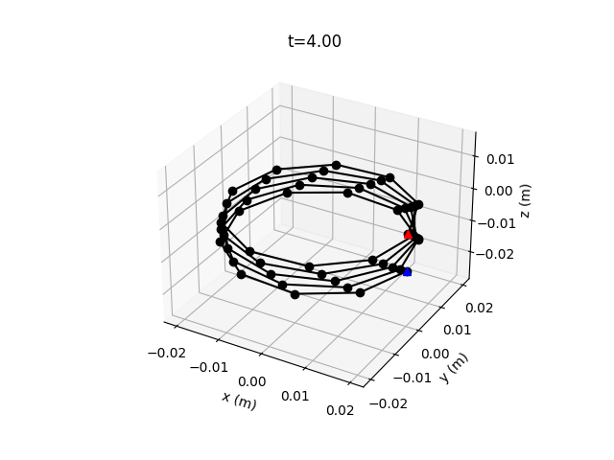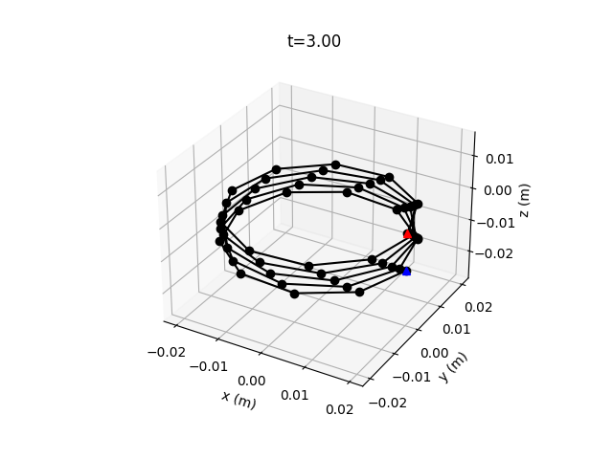
Figure 4: Snapshot of helix at t = 3.0s

Figure 5: Snapshot of helix at t = 4.0s

To determine when steady state has been reached, the simulation tracks a two second range. If no value in this range has a percent difference larger than 1% with respect to the most recent time step, the simulation is considered to have reached steady state, and the loop is broken. The z position of the last node of the helix is plotted over time, and the steady state value is plotted. Figure 6 shows the system reaching steady state after the characteristic load is applied.

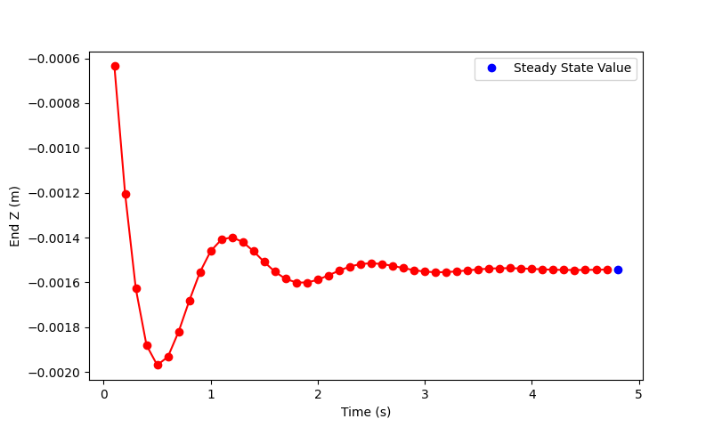
Figure 6. Z position of helix over time until steady state condition reached.

Part 2: Force Sweep and Linear Fit
To identify the spring constant of this spring, the axial force applied to the helix varied from 0.01 F_{char} to 10 F_{char} on a logarithmic scale. The resulting displacement of the end of helix was recorded for each step. Figure 7 shows the maximum displacement as a function of axial force applied to the helix. The inverse of the slope of this graph is the spring constant, K of the helix.
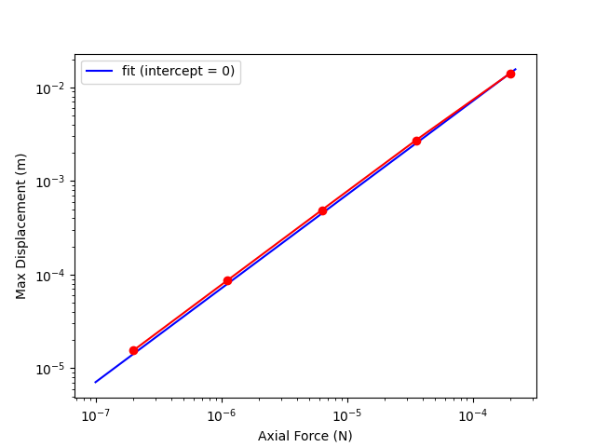
Figure 7: Helix maximum displacement (m) vs. Axial Force (n)

The slope of the blue line in Fig. 7 is the best fit given that the intercept is set to zero. This slope, the spring stiffness, was determined to be .014 N/m.

Part 3. Diameter Sweep vs. Textbook Trend
With a discrete elastic rod method for determining the spring stiffness of a helix, we can investigate the effects of changing helix parameters. In this assignment, the helix diameter varied from 0.01m to 0.05m. Ten helix diameter values were spaced linearly between these limits, and for each helix, a spring stiffness was determined. In each case, a range of forces were applied to the spring, and the steady state displacement was identified. A best fit line can identify the relationship between force and displacement, its slope being the inverse of the spring stiffness. In Figure 8, the stiffnesses of each helix is plotted as a function of the helix diameter. The resulting curve of these stiffnesses are compared to an analytical solution based on the equation:

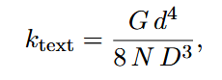

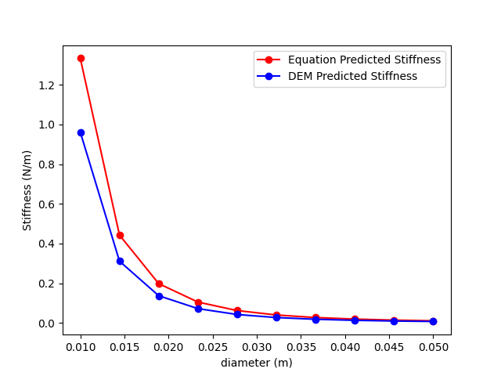
Figure 8: Helix stiffness as a function of helix diameter (Discrete elastic rod vs. Equation model)

At higher helix diameters, the equation and discrete elastic rod models predicted very similar stiffnesses. However, as the helix diameter became smaller, the prediction became less accurate. The reason for this change could be due to the dominance of the twisting effect being less effective with a smaller helix diameter. Instead, bending or stretching elastic force could come into play. The equation assumes dominance of twisting, and if other modes of deformation are occurring in smaller diameter helixes, it is possible that this causes the deviation. Although the deviation is present, the results of the discrete elastic rod model are convincing in their similarity to the analytical solution, and follow the anticipated trend of a reduction in stiffness as helix diameter increases.

- “25F-MECH&AE-263F-LEC-1 Mechanics of Flexible Structures and Soft Robots,” M. Khalid Jawed [Online]. Available: https://bruinlearn.ucla.edu/courses/216502.

